Doc Spot – Full Stack MERN Project Documentation

- Introduction
Project Title: DocSpot – Online Doctor Appointment Booking System
Team Member: medico centre

- Project Overview
Purpose:
DocSpot is designed to digitize and simplify the entire doctor appointment booking process. The primary purpose of the system is to eliminate traditional manual booking methods by offering a secure, fast, and user-friendly online platform. It provides patients, doctors, and administrators with seamless access to essential features such as real-time appointment scheduling, profile management, and data tracking.

DocSpot aims to:
  - Allow patients to easily find doctors based on specialization, availability, and location.
  - Provide a structured platform for doctors to manage appointments and patient interactions.
  - Enable administrators to manage users, doctors, approvals, and overall platform activities.
  - Improve healthcare workflow efficiency by reducing delays and manual effort.
  - Ensure secure and authenticated interactions using a robust MERN-based infrastructure.

Features:
  - User authentication (JWT-based)
  - Patient dashboard and appointment booking
  - Doctor dashboard for managing schedules and appointments
  - Admin panel to manage doctors, users, and appointments
  - Real-time notifications
  - Secure API integration

- Architecture
Frontend (React.js):
  - React with Hooks and Context API
  - Axios for API calls
  - Bootstrap/Material UI for styling
  - Protected routes using React Router

Backend (Node.js + Express.js):
  - RESTful API
  - Authentication middleware
  - Role-based access control

Database (MongoDB + Mongoose):
  - Collections: Users, Doctors, Appointments
  - Schema validation using Mongoose models

- Setup Instructions Prerequisites:
  - Node.js (v16+)
  - MongoDB or MongoDB Atlas
  - Git

Installation Steps:
- Clone the repository.
- Install dependencies for frontend & backend: npm install
- Configure .env in backend:
    - MONGO_DB="mongodb_connection_string"
    - JWT_SECRET="your_secret"
- Start frontend & backend.
- Folder Structure
  - Client (React):
    - /src/components – UI Components
    - /src/pages – Screens
    - /src/context – Global state
    - /src/utils – Helper functions

  - Server (Node.js):
    - /routes – API routes
    - /controllers – Business logic
    - /models – Mongoose schemas
    - /middleware – Auth & security layers

- Running the Application
Frontend: npm start
Backend: nodemon index.js
- API Documentation ➢ User APIs:
  - POST /api/user/register – Register user
  - POST /api/user/login – Login user • GET /api/user/profile – Get user profile ➢ Doctor APIs:
  - POST /api/doctor/apply – Apply as doctor
  - GET /api/doctor/appointments – Get doctor appointments • POST /api/doctor/update-status – Update appointment status ➢ Appointment APIs:
  - POST /api/appointment/book – Book appointment
  - GET /api/appointment/user-appointments – User appointments
  - POST /api/appointment/check – Check availability
  - Admin APIs
  - GET /api/admin/get-all-doctors – Fetch all doctors
  - POST /api/admin/update-doctor-status – Approve/Reject doctor
  - GET /api/admin/get-all-users – Fetch all users
  - GET /api/admin/all-appointments – Fetch all appointments
- Authentication:
  - JWT-based authentication
  - Tokens stored in local Storage • Role validation: user, doctor, admin 9. User Interface:
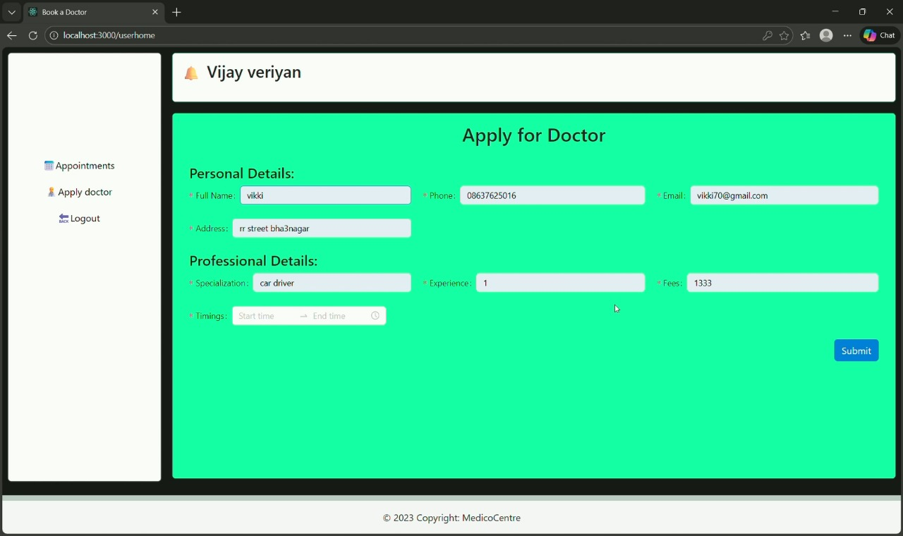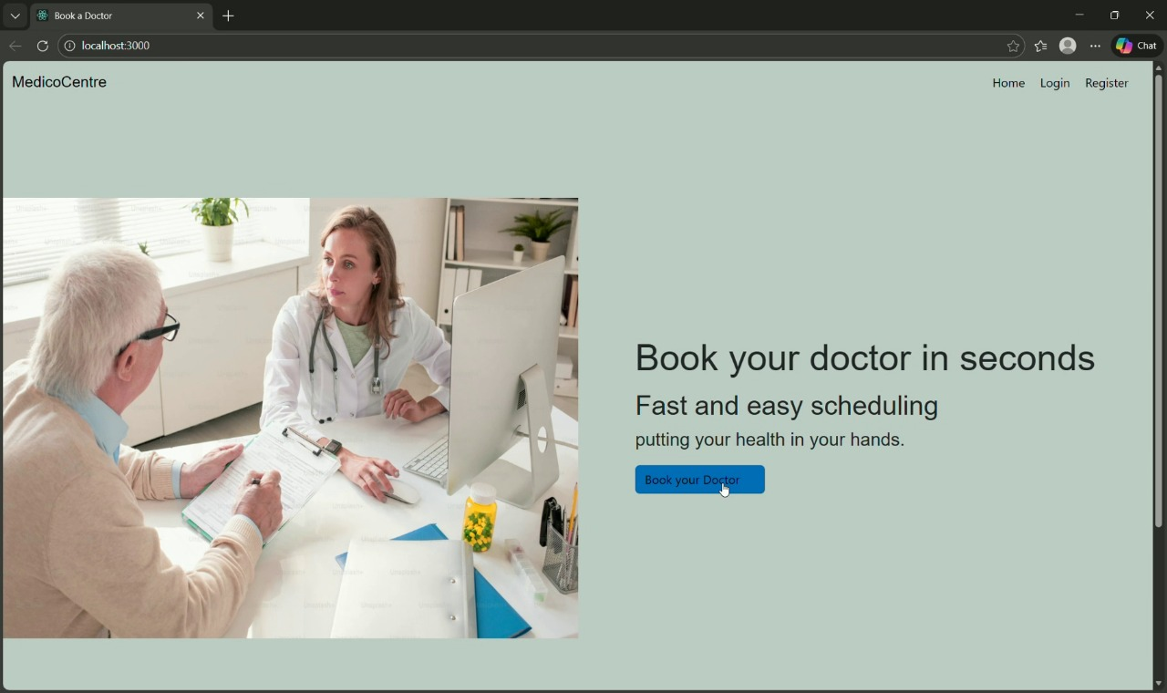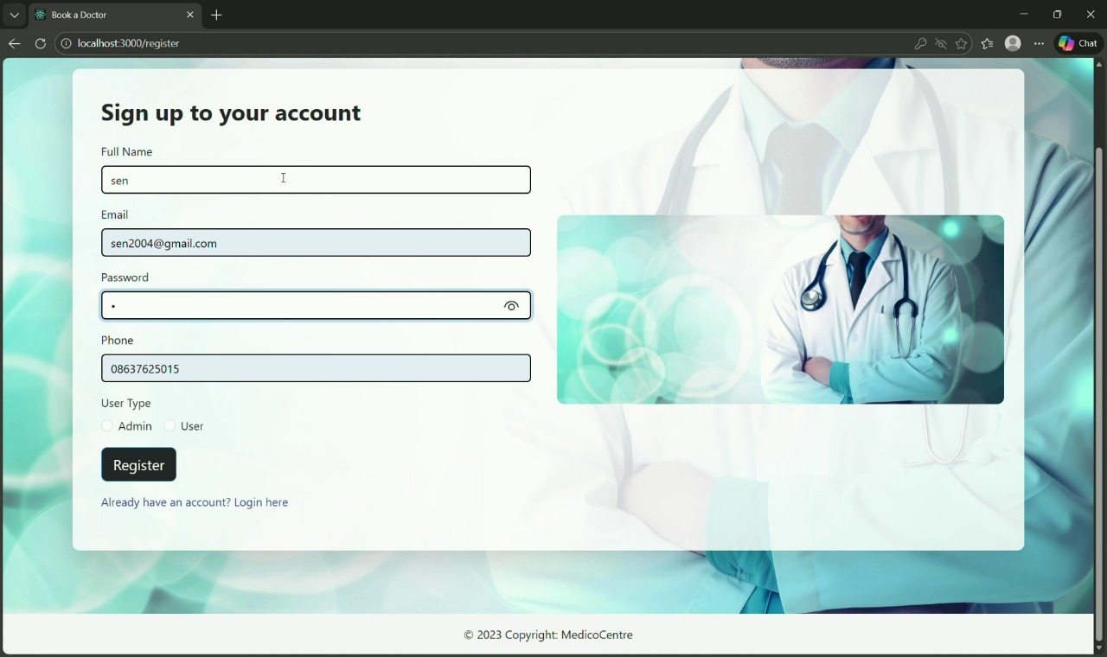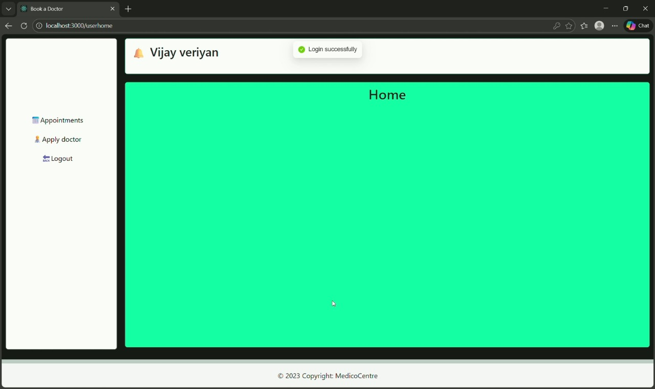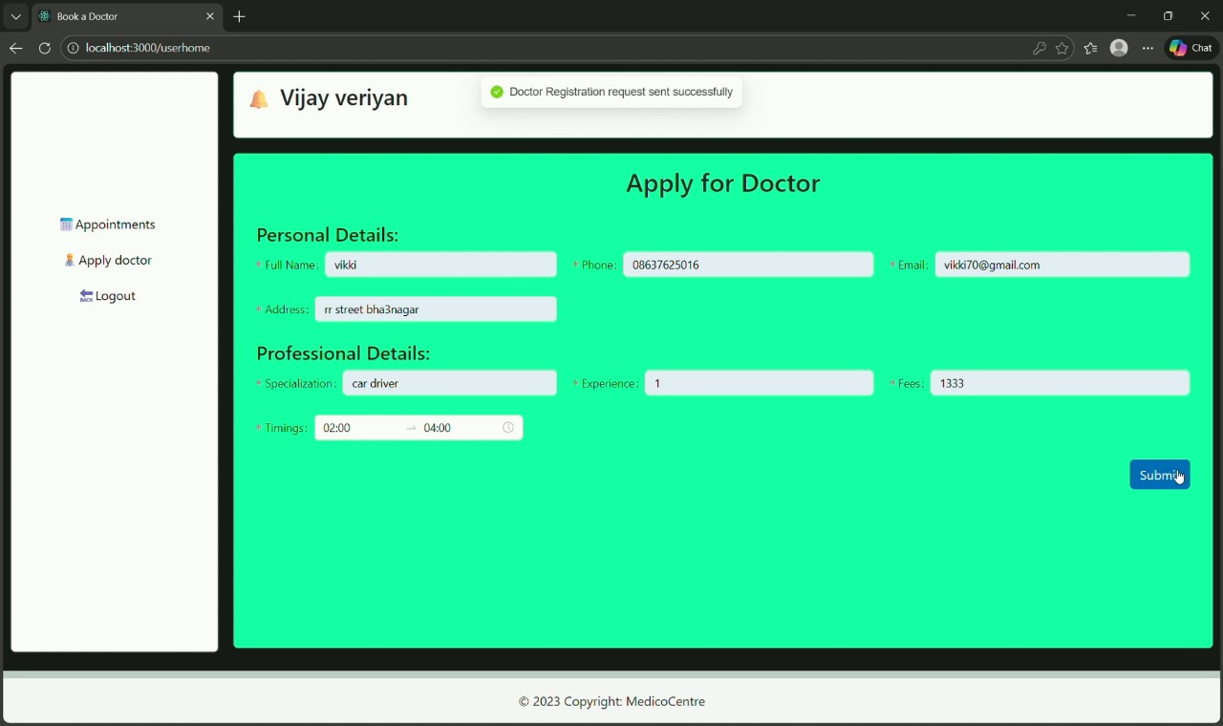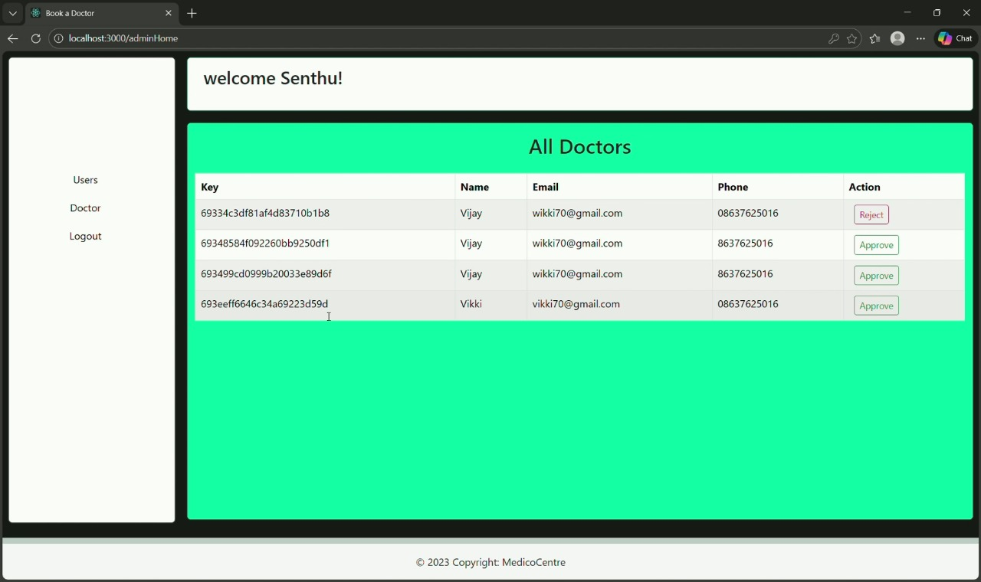

- Testing:
  - Manual testing
  - JWT verification and API endpoint tests

- Screenshots or Demo:
(Add demo/video links)

- Known Issues:
  - Occasional delay in backend responses
  - Admin panel UI improvements needed

- Future Enhancements:
  - Add payment integration
  - Add video consultation feature
  - Implement analytics dashboards

